Task 1
Match the pictures A-G with the sentences from the text to illustrate them 1-7. There’s one extra extract. Write down your answers into the answer sheet. Max 7 points

A
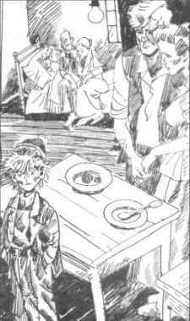

B
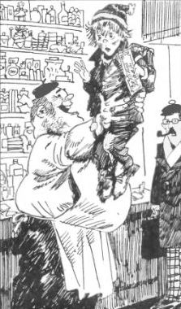

C
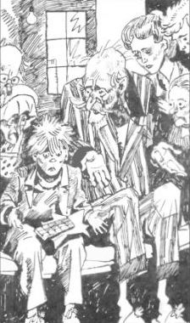

D
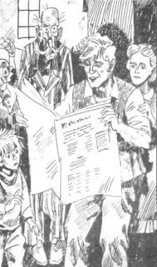

E
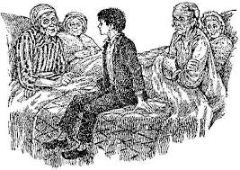

F
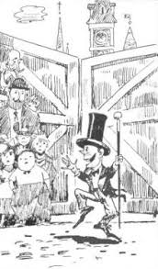
G
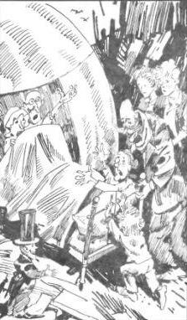

1. He held up the paper so that they could see the huge headline. The headline said:WONKA FACTORY TO BE OPENED AT LAST TO LUCKY FEW
2. The bed was given to the four old grandparents because they were so old and tired. They were so tired, they never got out of it.
3. So Mr Wonka and Grandpa Joe and Charlie, taking no notice of their screams, simply pushed the bed into the lift. They pushed Mr and Mrs Bucket in after it.
4. The only meals they could afford were bread and margarine for breakfast, boiled potatoes and cabbage for lunch, and cabbage soup for supper. Sundays were a bit better. They all looked forward to Sundays because then, although they had exactly the same, everyone was allowed a second helping.
5. The four old people, two at either end of the bed, propped themselves up on their pillows and stared with anxious eyes at the bar of chocolate in Charlie's hands.
Mr and Mrs Bucket came in and stood at the foot of the bed, watching Charlie.
The room became silent. Everybody was waiting now for Charlie to start opening his present.
6. It seemed as though the shopkeeper might be going to have a fit. 'In my shop, too!' he yelled. 'He found it right here in my own little shop! … Everybody wanted to get a look at the Golden Ticket and at the lucky finder. 'Where is it?' somebody shouted. 'Hold it up so all of us can see it!'
7. He kept making quick jerky little movements with his head, cocking it this way and that, and taking everything in with those bright twinkling eyes. Suddenly, he did a funny little skipping dance in the snow, and he spread his arms wide, and he smiled at the five children who were clustered near the gates, and he called out, 'Welcome, my little friends! Welcome to the factory!'
8. Graceful trees and bushes were growing along the riverbanks — weeping willows and alders and tall clumps of rhododendrons with their pink and red and mauve blossoms. In the meadows there were thousands of buttercups.

Task 2
QUESS “WHO”
Write down the names of the main heroes according to their description. Give a full name. Write down your answers into the answer sheet. Max 8 points

1.а boy who lives with six grown-ups in a small wooden house on the edge of a great town
2. a greedy boy
3. a girl who is spoiled by her parents
4. a girl who chews gum all day long
5. a boy who does nothing but watch television
6. the only person in the BUCKET family with a job, who works in a toothpaste factory
7. the most extraordinary chocolate maker in the world who invented more than two hundred kinds of chocolate bars
8. the tiny men, no larger than medium-sized dolls who dream about cacao beans all night and talk about them all day

Task 3
CROSSWORD
Do the crossword. Write down words into the answer sheet. Max 11 points

 |  |  |  | ²
 |  |  | ¹
 |  | ³ |  |  |  |  | ⁵
 |  |  |  |  |  |  |  |  | ⁸
 |  |  |  |  |  |  |  |  |  |  | ⁹ |  | ¹¹
 |  |  |  |  | ⁶
⁴
 |  |  | ⁷
 |  |  |  |  | ¹⁰

ACROSS
1. а piece of paper that wins you a prize
3. a tremendous fall of water halfway along the river
4. a day when someone is born
6. a sweet made of cacao beans
7. a monstrous gigantic thing spinning its wheels at breakneck speed
10. a large amount of water flowing somewhere
DOWN
2. a machine that carries people up or down between different levels of a tall building
5. a place where sweets and chocolate are made
8. someone who owns or manages a shop
9. a person who uses magic to make impossible things
11. a thing with a screen for watching programmes

Task 4
SWEET jumble words
Make up a word of the following letters. Write down only one word into the answer sheet. Max 10 points

1. O C E L O H C T A
2. W A H M L S M S O R A L
3. W C U G H I G M E N
4. S A I P N H E S P
5. E U G F D
6. C C E E M I A R
7. M A L C E A R
8. O V E L
9. R W S B E R A T Y R
10. M E C A R

Task 5
ODD WORDS
Cross the odd word out.Write down only one word into the answer sheet. Max 5 points

1. Amazing Extraordinary Devastating Fantastic ( MR Wonka)
2. Wealthy Starving Freezing Poor ( Charlie's family )
3. Enormous Exciting Monstrous Greedy ( Augustus)
4. Secret Magic Ordinary Present ( Golden Ticket)
5. Tremendous Graceful Finest Flabbergasted ( Chocolate room)

Task 6
LOGICAL ORDER
Put the following extracts into logical order 1-12. Write down your answers into the answer sheet. Max 12 points

a. The five lucky finders of these five Golden Tickets are the only ones who will be allowed to visit my factory and see what it's like now inside! Good luck to you all, and happy hunting!
b. Mr Wonka was standing all alone just inside the open gates of the factory… Then suddenly, Mr Wonka stopped. In front of him, there was a shiny metal door. On the door, in large letters, it said: THE CHOCOLATE ROOM
c. Not so very long ago there used to be thousands of people working in Mr Willy Wonka's factory. Then one day, all of a sudden, Mr Wonka had to ask every single one of them to leave, to go home, never to come back.
d. Charlie picked it up and tore off the wrapper … and suddenly … from underneath the wrapper … there came a brilliant flash of gold. 'It's a Golden Ticket! The kid's found Wonka's last Golden Ticket! There it is! It's right here in his hands!'
e. In the town there was an ENORMOUS CHOCOLATE FACTORY! It was WONKA'S FACTORY, owned by a man called Mr Willy Wonka, the greatest inventor and maker of chocolates that there has ever been.
f. Suddenly there was a shriek, and then a splash, and into the river went Augustus Gloop, and in one second he had disappeared under the brown surface. 'Save him!' screamed MrsGloop.
g. So Mr Wonka and Grandpa Joe and Charlie simply pushed the bed into the lift. They pushed Mr and Mrs Bucket in after it. Then they got in themselves. Mr Wonka pressed a button. The doors closed. And the lift rose up off the floor and shot through the hole in the roof, out into the open sky.
h. Her face and hands and legs and neck, in fact the skin all over her body, as well as her great big mop of curly hair, had turned a brilliant, purplish-blue, the colour of blueberry juice!
i. Mike Teavee started running as fast as he could towards the other end of the room where the great camera was standing. 'Look at me!' he shouted as he ran. 'I'm going to be the first person in the world to be sent by television!'
j. In five seconds they were a thousand feet up in the sky. Mr Wonka pressed another button. The lift stopped. Looking down through the glass floor, Charlie could see the small far-away houses and the streets and the snow …
k. Mr Bucket, Charlie's father, came into the room and he was waving an evening so that they could see the huge headline. The headline said: WONKA FACTORY TO BE OPENED AT LAST TO LUCKY FEW
l. Veruca struggled furiously, but the squirrels held her tight and she couldn't move. Then all at once, the squirrels pulled Veruca to the ground and started carrying her across the floor.

Task 7
THICK QUESTIONS
Answer the following questions. Write down your answers (1-3 words) into the answer sheet. Max 30 points

1. What did Charlie long for more than anything else?
2. What did Mr. Wonka recommend Prince Pondicherry?
3. What was the only thing known about new factory workers?
4. How old was the first Golden Ticket finder?
5. What did Charlie's family eat for supper?
6. What happened to the factory Mr. Bucket was working?
7. How much money did Charlie found?
8. Who took Charlie to the factory gate?
9. What time did the factory's great iron gate began to swing open at?
10. What was the factory like inside?
11. What was the nerve center of the whole factory?
12. Where did the pipe - the one Augustus went up - lead directly to?
13. What did a gigantic machine in the very center of the Inventing room produce?
14. How many people left in the group after visiting the Nut room?
15. How did Mr. Wonka feel when Charlie named his factory as the most wonderful place in the world?

Task 8
CREATIVE STORY
Create your own ending of the story and write 10-12 sentences “The Buckets’ life
at the CHOCOLATE FACTORY”. Max 12 points

______________________________________________________________________________________________________________________________________________________________________________________________________________________________________________________________________________________________________________________________________________________________________________________________________________________________________________________________________________________________________________________________________________________________________________________________________________________________________________________________________________________________________________________________________________________________________________________________________________________________________________________________________________________________________________________________________________________________________________________________________________________________________________________________________________________________________________________________________________________________________________________________________________________________________________________

